We Have found out the following;
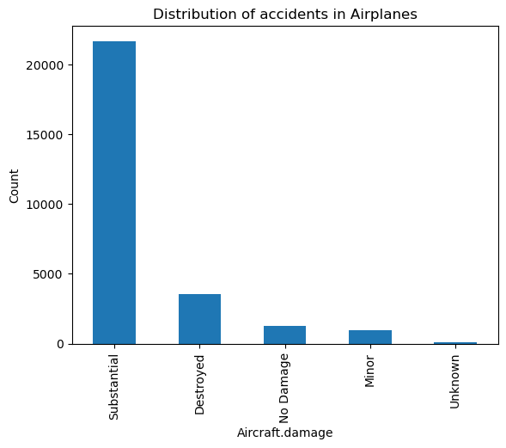

Airplane tend to take damage however there are very few cases of completely destroyed planes thus we can go into the plane business.
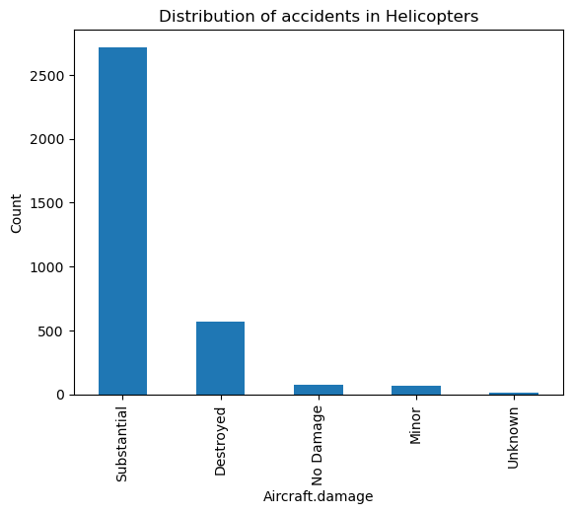

Helicopters seem to get destroyed more frequently as we can see the distribution is roughly at 20% against those that survive.
Also as a note, there are far fewer cases of crashes in helicopter than with Airplanes thus proving that this would be a suitable venture.

